***Poème électronique***

Gascia Ouzounian

An eight-minute long multimedia spectacle held in the Philips Pavilion at the 1958 BRUSSELS WORLD'S FAIR. Conceived by the Swiss French architect Le Corbusier, the pavilion combined the efforts of a leading group of artists and architects who included French-born composer Edgard Varèse and Greek architect/composer Iannis Xenakis. The name *Poème électronique* refers both to the overall project, as well as to Varèse's musical contribution, an eight-minute electro-acoustic composition that was broadcast over hundreds of loudspeakers inside the pavilion. *Poème électronique* is regarded as an iconic *Gesamtkunstwerk* (total artwork) that combined music, hanging sculptures, film, automated lighting schemes, and architecture in the context of an immersive, multimedia installation.

**Overview:**

In January1956, the Philips Corporation, a Dutch multinational firm based in Eindhoven, Netherlands, approached Le Corbusier to design its pavilion for the upcoming World's Fair. The corporation had intended to hire Le Corbusier along with the Belarusian sculptor Ossip Zadkine and the British composer Benjamin Britten. However, upon meeting Louis Kalff, the director of the Philips Corporation's artistic division, Le Corbusier became convinced that he should instead create an "electronic poem". He wrote:

I will not make a façade for Philips, but an electronic poem. Everything will happen inside: sound, light, color, rhythm. Perhaps a scaffolding will be the pavilion's only exterior aspect.

The Philips Corporation accepted Le Corbusier's proposal, although it never warmed to his choice of musical collaborator. Although Edgard Varèse was well regarded in avant-garde circles, he did not have the international stature of Benjamin Britten, nor was his music thought to have popular appeal. However, Le Corbusier insisted on hiring Varèse, making this a condition of his own participation in the project. Varèse enthusiastically welcomed the commission, which came directly to him from Le Corbusier.

The principal collaborators all worked in different parts of the world throughout the project. Le Corbusier was based in Chandigarh, India, where he was tasked with designing an entire city; Xenakis worked out of Le Corbusier's Paris studio, where he was employed as an architectural assistant; Varèse created the music in an electronic music studio in Eindhoven that was built especially for that purpose. There was no co-ordination between the different parts, save for a "story of all humankind" conceived by Le Corbusier as a general thematic device that would tie together the different elements of the work.

The Philips pavilion opened on 17 April 1958, although it closed immediately for several weeks due to technical difficulties. It re-opened on 20 May 1958, closed at the end of September 1958, and was destroyed on 30 January 1959. During the four months it was open to the public, *Poème électronique* was screened sixteen times a day to an audience of 500 people per screening. Over one million people experienced the work, and it was widely discussed in leading newspapers and journals of the period.

**Architecture:**

The striking exterior shell of the pavilion was designed by Ianis Xenakis according to a sketch by Le Corbusier. A trainedcivilengineer, Xenakis created a design based on hyperbolic paraboloid functions, and is thought to have introduced a completely new element in architecture through his designs for the pavilion. A dispute over authorship ultimately ensued, whereby Le Corbusier did not wish to grant Xenakis credit as co-author of the pavilion's architecture. This lead to a professional rift between the two architects, and Xenakis left Le Corbusier's studio in 1959.

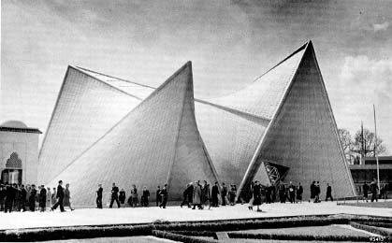 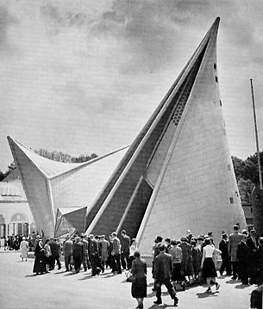

Crowds gather outside *Poème électronique* at the 1958 Brussels World's Fair.

Photos by Hans de Boer. ©Le Corbusier, Iannis Xenakis, Edgard Varèse.

http://www.medienkunstnetz.de/works/poeme-electronique/images/2/

http://www.medienkunstnetz.de/works/poeme-electronique/images/3/

**Music:**

Since the 1930s, Varèse had dreamt of new devices that would enable him to create spatial music. However, it was not until the Philips Pavilion commission that he had the means to create spatial music on a significant scale. Working with a team of audio engineers lead by Willem Tak in the Eindhoven studio, Varèse composed a complex electro-acoustic work that usedhundreds of pre-recorded and electronically synthesized sounds. Information relating to the sounds' location and movement inside the pavilion was encoded onto multi-track tape, and broadcast over nine "sound routes" to an estimated 300-425 loudspeakers inside the pavilion. This resulted in an unprecedented immersion in sonic space for listeners, who reported singularly visceral responses to Varèse's music.

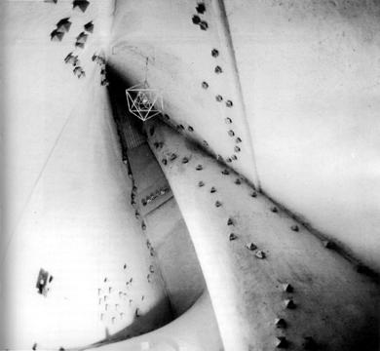

Loudspeakers lining the interior walls and ceiling of *Poème électronique*, 1958. ©Le Corbusier, Iannis Xenakis, Edgard Varèse.

http://www.medienkunstnetz.de/works/poeme-electronique/images/4/

The music itself was dense and contained striking juxtapositions. The first minute of music alone featured the rhythmic striking of a gong, percussive sounds, electronic pulses of varied durations and amplitudes, sine tones, buzzing and quacking sounds, the sound of glass, a synthetic *glissando*, and sirens. Sirens featured prominently in the work, acting as a musical allusion to the pavilion's exterior architecture. The music also featured recordings of a solo female voice and male choir, as well as bells, machine noises, animal noises, wood blocks, and an organ, among other source sounds.

In addition to his architectural designs, Xenakis created a two-minute musical interlude, *Concret PH*, which was broadcast while audiences were ushered in and out of the pavilion.

**Critical reception and legacy:**

Reviews of *Poème électronique* were mixed, with critics expressing everything from puzzlement to wonderment. According to architectural historian Marc Trieb, "The public was often mystified by the presentation they watched and heard within the pavilion. [...] While few—if any—would claim to understand the Varèse score, or to find it beautiful, a handful of critics felt that they were in the presence of something profound" (Trieb, 1996). Varèse himself excitedly claimed that, for the first time in his life, he heard his music "literally projected into space" (Varèse, 1998 [1959]).

*Poème électronique* is considered one of the most significant electro-acoustic works of the twentieth century, even as the original spatial effects cannot be heard on stereophonic recordings. The work secured Varèse's place among the leading composers of the century, and inspired numerous composers and artists to explore the spatial properties of sound. In 2005, the Italian computer scientist and audiovisual engineer Vincenzo Lombardo led the EU project *Virtual Poème électronique*, a virtual reality reconstruction of *Poème électronique*.

**References and further reading:**

Le Corbusier (1958) *Le Poème électronique: Pavilion Philips pour l'Exposition universelle de Bruxelles 1958*, Paris: Éditions de Minuit.

Meyer, F. and Zimmerman, H. (eds.) (2006) *Edgard Varèse: Composer, Sound Sculptor, Visionary*, Woodbridge: Boydell Press.

Trieb, M. (1996) *Space Calculated in Seconds*, Princeton: Princeton University Press.

Varèse, E. (1998 [1959]) "Spatial Music" in E. Schwartz, B. Childs, and J. Fox (eds.) *Contemporary Composers on Contemporary Music*, 204-207. New York: Holt, Rinehart and Winston.

Varèse, E. (2004 [1936]) "The Liberation of Sound" in C. Cox and D. Warner (eds.) *Audio Culture: Readings in Modern Music*, 17-21. New York: Continuum.

**Discography:**

Varèse, E. (1960-62) *Music of Edgard Varèse*, New York: Columbia Masterworks ML 5478, 5762.

**Audio-visual resources:**

Le Corbusier and Varèse, E (1958) Film and music for *Poème électronique*: http://www.ubu.com/film/varese.html

Lombardo, V. et al (2005) *Virtual Electronic Poem Project: A Virtual Reconstruction of the Poème électronique*: http://www.edu.vrmmp.it/vep/